  As a parent, we hope you will help us in our legal duties to protect all our pupils. As a school, we have a duty to contact Cardiff MASH (Multi-Agency Safeguarding Hub) where we are concerned that a child may be at risk or suffering harm. Sometimes we may need to speak to you about your child and your circumstances.  Nobody in the school will judge or accuse you, we simply need to discuss the facts and decide whether you may need some extra help to give your child every opportunity they deserve.  This leaflet outlines some of the standard procedures the school MUST follow. None of these procedures are designed to upset or distress you as parents/ carers. They are designed to look at your child’s needs and make sure that if your child needs some extra help, he/ she gets it. | 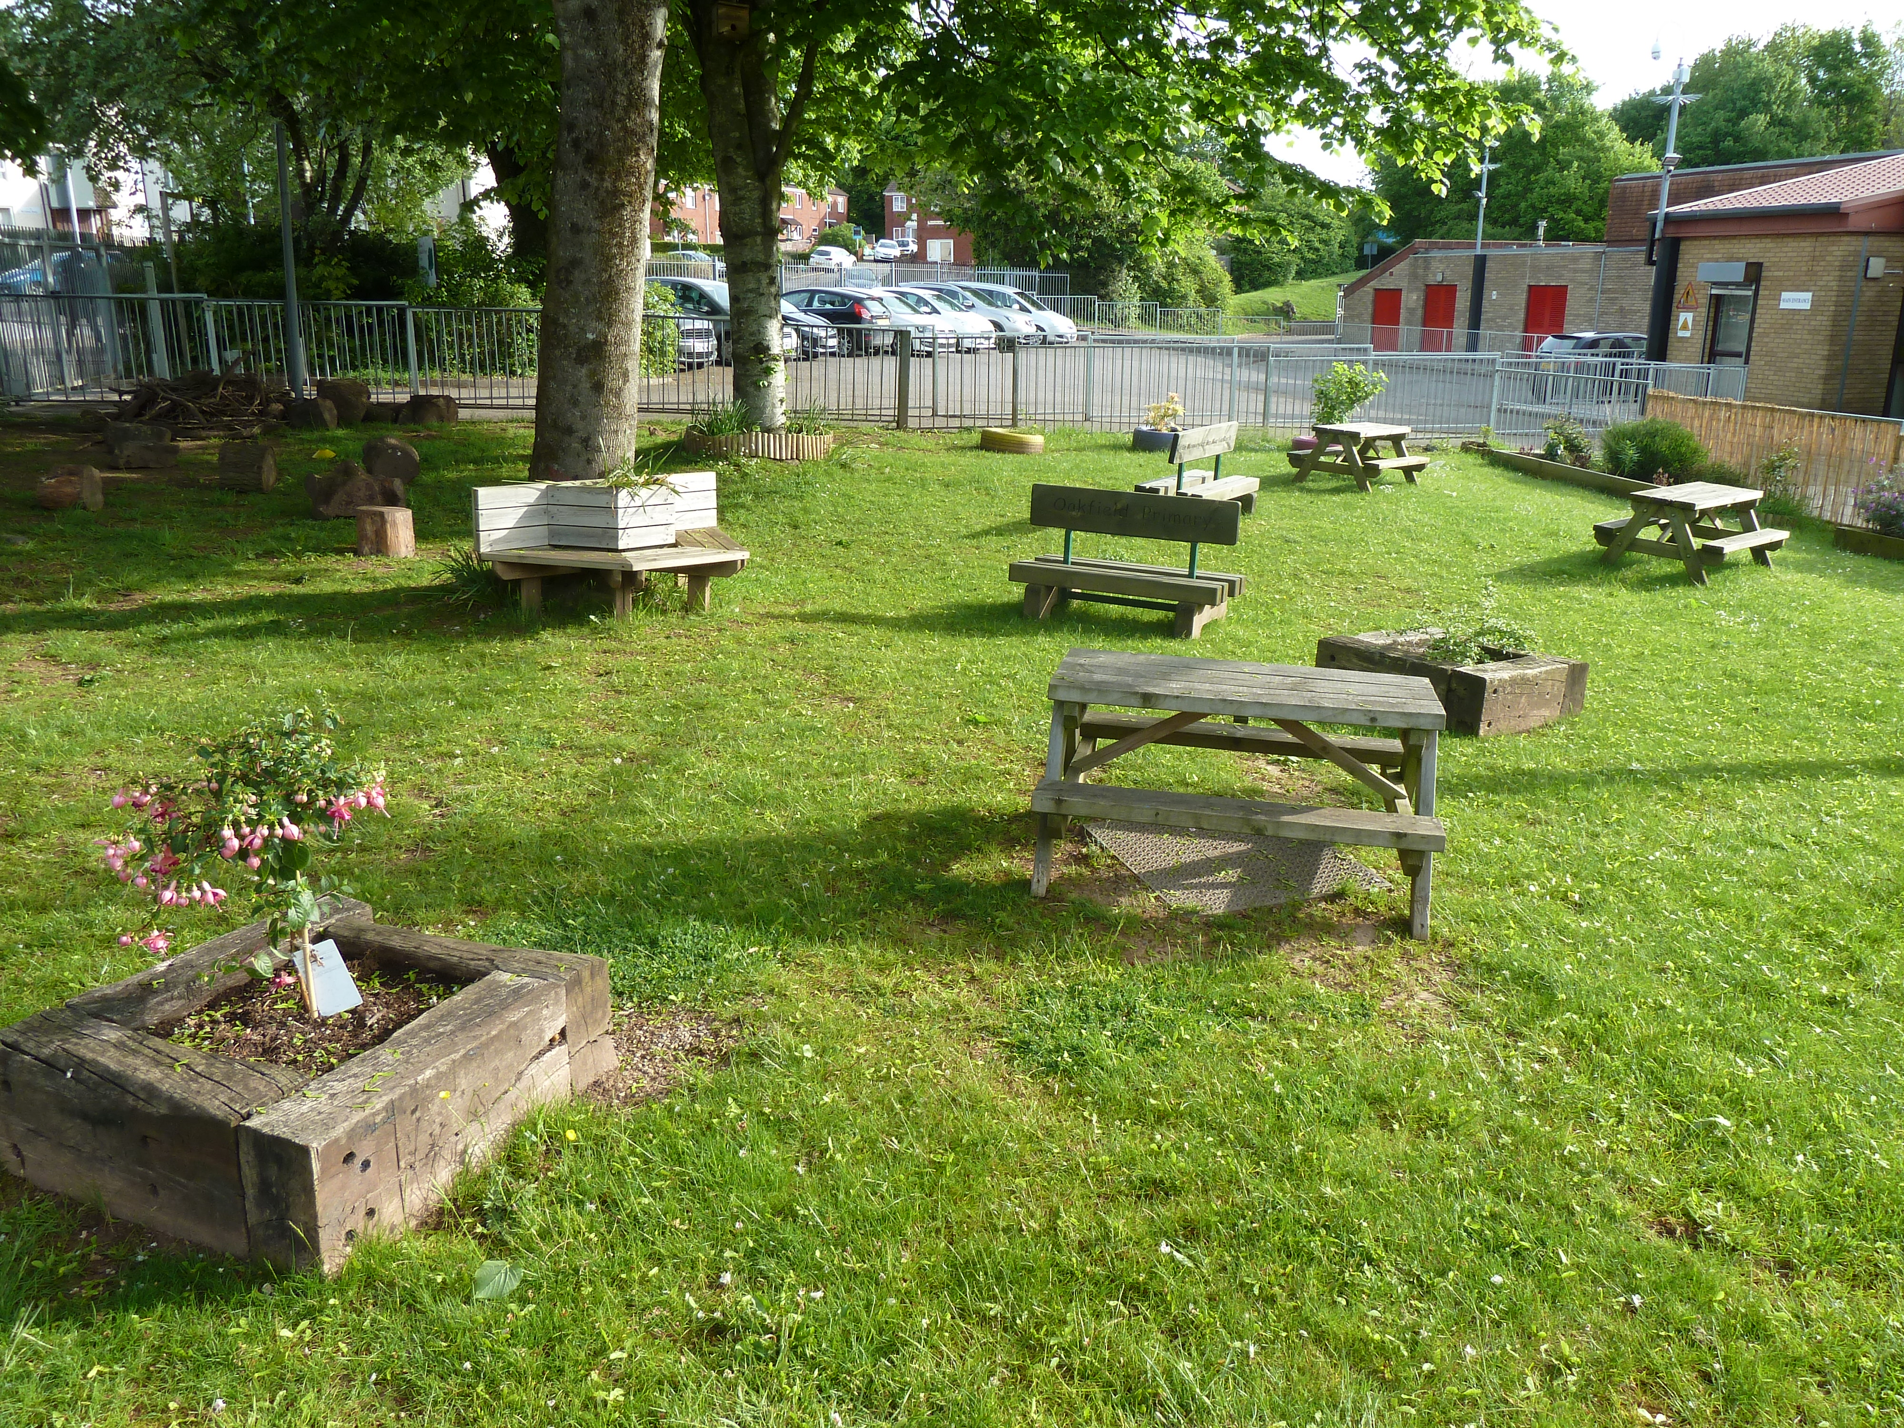  yyyy  Our Child Protection Policy applies to all staff, governors and volunteers working in the school. The five main points are:  - Ensuring we check the suitability of staff and volunteers to work with children.  - Raising awareness of child protection issues and equipping children with the skills needed to keep themselves safe.  - Making sure school procedures for identifying and reporting concerns are followed.  - Supporting pupils who are at risk, in line with his/ her agreed child protection plan.  - Having a safe and secure environment in which children can learn and develop. |  | Child Protection at  Oakfield Primary School  - At Oakfield Primary School, we value our children and their futures. With this in mind, we have a Child Protection Policy designed to keep our pupils as safe as possible.  As a parent or carer of our pupils you have a vital role to play. This school is part of your community and you are vital in helping us keep pupils safe.  Child Protection Officers:  Mr. D Harris and Mrs. N Mears  Mrs.  Mrs

Staff will:  - Remember that the priority is to protect the child and tread the matter seriously;  - Listen but not judge;  - Believe the child;  - Tell the child that they have done the right thing in telling;  - Tell the child what will happen next where possible and  - Inform the Headteacher or Deputy Headteacher of all concerns immediately  Staff will not:  - Contact the parents – this is the job of the Headteacher or Deputy Headteacher or Cardiff MASH;  - Ask lots of questions if a child has disclosed concerning information;  - Speak to anyone about whom allegations are made (including colleagues), or  - Promise to keep secrets  When school staff have concerns for a child. The Headteacher or Deputy Headteacher sill usually discuss this with the parents, but in some circumstances this will not be possible and Cardiff MASH will need to be called instead. |   - The parent knew the concerns and did not protect the child;  - The parent is the cause and/ or  - The parent would not be able to discuss the concern.  As a parent/ carer you play a vital role in all that the school does, especially when it comes to ensuring all our pupils are safeguarded and protected. As a school we ask that you as a parent/ carer:  - Talk to staff about any concerns you have for your child;  - Remember that the school MUST share concerns about your child;  - Recognise that the school will NOT judge you, but the school may have to share difficult information and  - Understand, the school MUST prioritise the safety and wellbeing of pupils. They cannot keep secrets from other agencies. | Child Protection concerns can involve:  - Children telling staff or other pupils that they are concerned about abuse or neglect issues;  - Children having injuries;  - Children behaving in a way that is unusual for their age and understanding e.g., sexual knowledge;  - Children being dirty or poorly dressed;  - Children who are overly hungry or tired and  - Children who are frightened, overly aggressive or there is a sudden change in their behaviour.  There are many way which staff might become concerned about a child. The School will always want to assist the child and the family. Discussions with parents are intended to support the family not accuse anyone.  Please help our school make sure all our children are safe and feel secure at home and in school.  www.oakfieldprimary.com  Cardiff MASH - 02920536490

