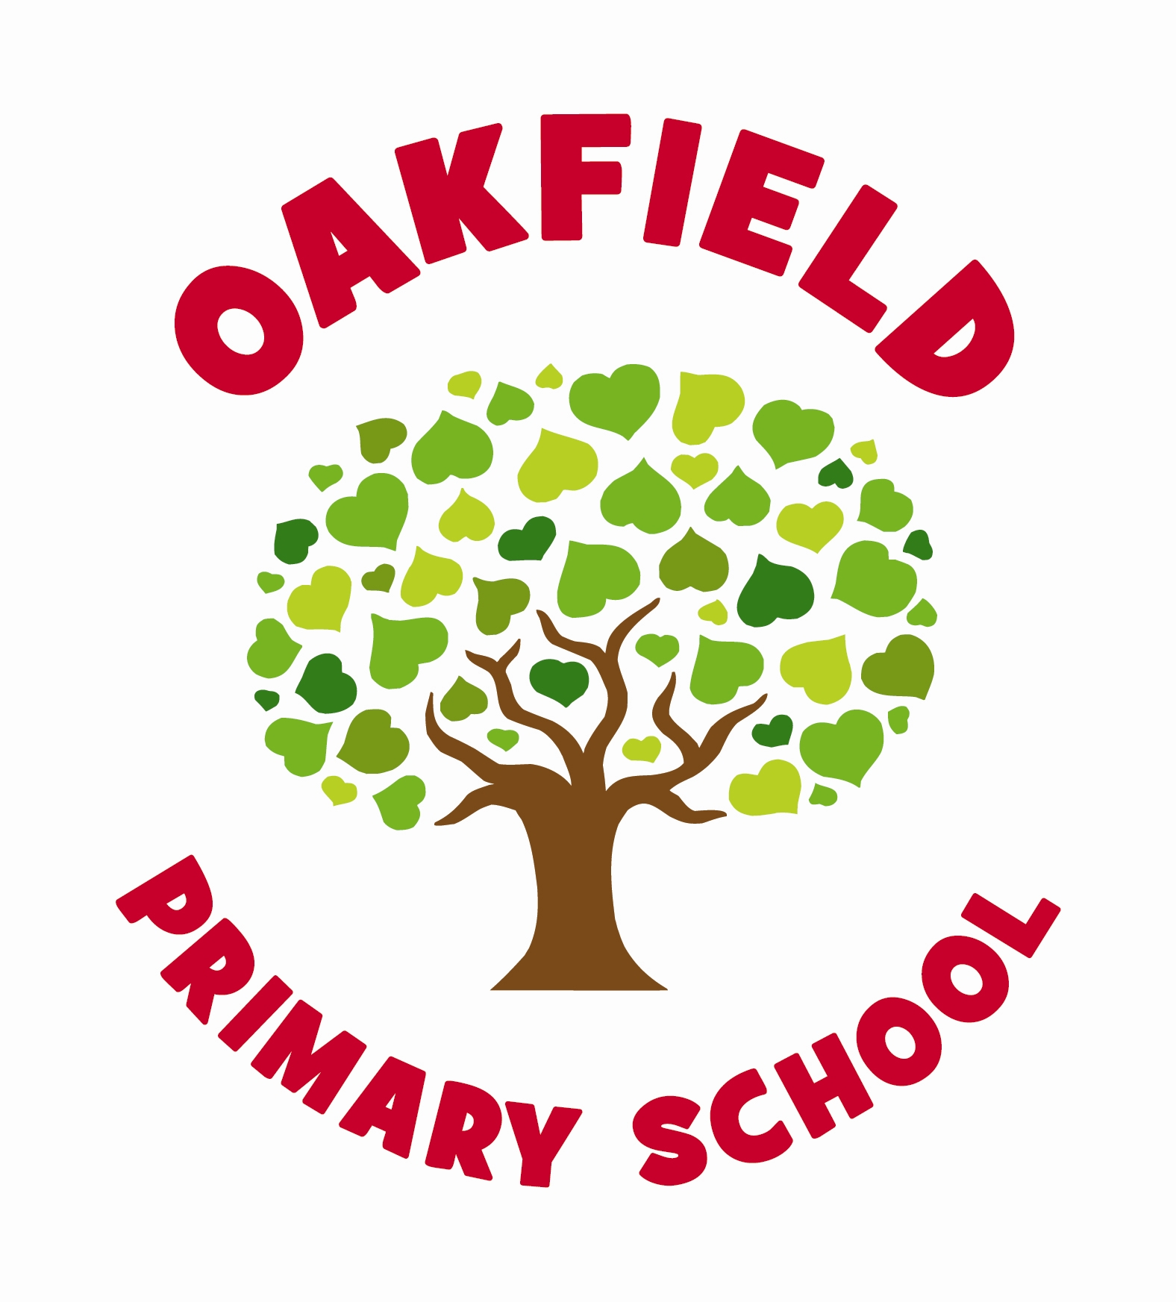School Council Meeting Minutes: 18/10/19

Present: SS, AH, KF, MD, MBH, CJ, PJ, ES, MC, KB, Mr Hiscock.
Abs: KSM
Google classroom. | All council members (Not KSM abs, Y3 or 2.) have now joined the school council class and have access to tasks.  Further Action: Speak to Y2+3 teachers for Google Log ins. KSM to log in when back.
School improvement ideas for the year. | Pupils have recorded ideas for school improvement on a collaborative Google doc.  Further Action: Speak to KSM for her ideas.
2019/2020 Action Plan. | Pupils have created a joint action plan for targeted areas they would like to focus on for the year.  Target 1: Decorating and painting of key walls around the school.  Target 2: Fundraising for resources.  Target 3: Look into comfy furniture for book corner areas.  Further Action: Pupils to feed back to classes through their school council books.
AOB | Pupils have been shown Cardiff Children’s survey to be completed W/B 21.10.19.  Further Action: Pupils to discuss with classes and assist teachers.

