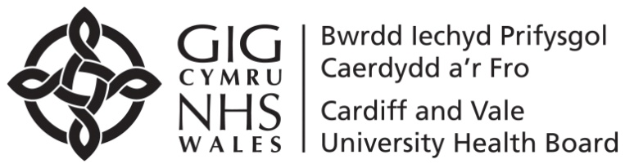

1st Floor
Woodlands House
Maes Y Coed Rd
Cardiff
CF14 4TT
Tel: 02921 832071

CHILDREN AND WOMEN DIVISION
CHILD HEALTH DIRECTORATE
SCHOOL NURSING SERVICE
Date…JANUARY 2022

East SN Team-02920734161
West SN Team- 02920907661
Vale SN Team -01446704114
Dear Parent/Guardian

The School Health Nurse will be visiting your child’s school in the near future to carry out height, weight and vision screening for all reception children as part of the School Health Screening Programme. Hearing will also be checked during the year.

If you would like to meet with the School Health Nurse to discuss any concerns you may have about your child’s health now that they have started school, please contact her/him on the above number.

If you do not wish your child to be routinely screened by the School Nurse, please let her/him know within seven days of receipt of this letter.

Yours sincerely

School Health Nurse
Encl.

Llawr 1
Ty Coetir
Ffordd Maes Y Coed
Llanishen
Caerdydd
CF14 4TT

Tel: 02921 832071

ISADRAN PLANT A MENYWOD

CYFARWYDDIAETH IECHYD PLANT

GWASANAETH NYRSIO YSGOLION

Dyddiad……January 2022……………………………

East SN team -02920734161
West SN Team-02920907661
Vale SN team-01446704114

Annwyl Riant/Warcheidwad

Bydd y Nyrs Iechyd Ysgolion yn ymweld ag ysgol eich plentyn yn y dyfodol agos er mwyn sgrinio taldra, pwysau a golwg yr holl blant dosbarth derbyn fel rhan o’r Rhaglen Sgrinio Iechyd Ysgolion. Caiff y clyw hefyd ei wirio yn ystod y flwyddyn.

Os hoffech gwrdd â’r Nyrs Iechyd Ysgolion i drafod unrhyw bryderon a allai fod gennych am iechyd eich plentyn, nawr ei fod wedi dechrau’r ysgol, cysylltwch â hi/ef ar y rhif uchod.

Os nad ydych am i’ch plentyn gael ei wirio gan y Nyrs Ysgol fel rhan o’r drefn arferol, gadewch iddi/iddo wybod o fewn saith niwrnod i dderbyn y llythyr hwn.

Yn gywir

Nyrs Iechyd Ysgolion
Amg

