Dear Parent/Guardian

The School Health Service/Child Measurement Programme for Wales

Welsh Government has set up the Child Measurement Programme for Wales. This surveillance programme is run by Public Health Wales and is designed to help us better understand patterns of children’s growth across the whole of the country. The height and weight of each child in a reception class in Wales will be measured. Measurements will be taken in a school setting by a trained member of the healthcare team. Children will be asked to wear normal light clothing and take off their shoes.

This information helps the NHS improve the health services provided for children, including those that help them maintain a healthy weight. All information used by the programme will be treated confidentially and no information identifying your child will ever be published.

If you are happy for your child to participate in this programme you do not need to do anything more. However, if you do not wish your child to be included, please let the school nursing service know by returning the tear-off slip below.

More information about the child measurement programme is available on a separate leaflet as well as on the NHS Public Health Wales website:
www.publichealthwales.org/childmeasurement

Yours sincerely

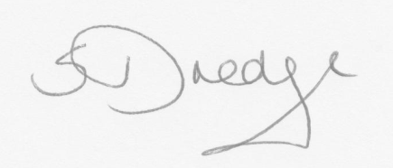

Sandra Dredge. Senior Nurse, for Community Child Health Nursing.

I do not wish my child to take part in the Child Measurement Programme

My child………………………………………..d.o.b. (………/………/……….)
(please write name of child and date of birth)

Signed…………………………………….(parent/guardian) Date:……………….

Annwyl Riant/Warcheidwad

Gwasanaeth lechyd Ysgolion/Rhaglen Mesur Plant Cymru

Mae Llywodraeth Cymru wedi sefydlu Rhaglen Mesur Plant I Gymru. Cynhelir y rhaglen oruchwyllaeth hon gan Iechyd Cyhoeddus Cymru a’l bwriad yw ein cynorthwyo I gael gwell dealltwriaeth am batrymau twf plant ledled y wlad. Mesurir taldra a phwysau pob plenty mewn dosbarth derbyn yng Nghymru. Gweneir y Mesuriadau yn yr ysgol gan aelod wedi ei hyfforddi o’r tim gofal lechyd. Gofynnir I’r plant wisgo dillad ysgafn arferol a thynnu eu hesgidiau.

Mae’r wybodaeth hon yn cynorthwyo’r GIG I wella’r gwasanaethau lechyd a ddarperir I blant, yn cynnwys y rheiny sy’n eu cynorthwyo I gynnal pwysau iach. Caiff yr holl wybodaeth a ddefnyddir gan y rhaglen ei thrin yn gyfrinachol ac ni chaiff unrhyw wybodaeth y gellir adnabod eich plentyn drwyddi ei chyhoeddi byth.

Os ydych yn fodlon I’ch plentyn gymryd rhan yn y rhaglen hon nid oes angen I chi wneud dim byd arall. Fodd bynnag, os nad ydych am I’ch plentyn gael ei gynnwys, dywedwch wrth y gwasanaeth nyrsio ysgolion drwy ddychwelyd y slip y gellir ei ddatgysylltu isod.

Mae rhagor o wybodaeth am y rhaglan mesur plant ar gael ar daflen ar wahan yn ogystal ag ar wefen Iechyd Cyhoeddus Cymru Y GIG
www.publichealthwales.org/childmeasurement

Yn gywir

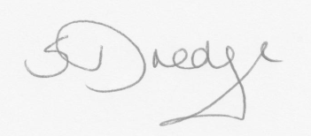

Sandra Dredge
Uwch Nyrs Iechyd Cymdeithasol

___________________________________________________________

Nid wyf am I’m plenty gymryd rhan yn y Rhagln Mesur Plant

Fy mhlentyn……………………………………….. D.G. (………/………/……….)
(ysgrifennwch enw a dyddiad geni’r plentyn)

Arwyddwyd…………………………(rhiant/gwarcheidwad) Dyddiad……………

