Language, Literacy and Communication  LLC | Expressive Arts | Health and Well-Being | 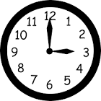  Maths and Numeracy  TTRockStars  Practice logging into TTRockstars to practice your times table knowledge and Numbots.
  Practise your spellings by completing: look, read, say, cover, write, check.  Let’s see who will get full marks this term!  Why not test someone in your family on the words? Be the teacher! | Expressive Arts – Creative  Can you draw your favourite land or sea animal and the habitat that they live in. Can you add some interesting facts to your work?  Send us a picture of your creation!  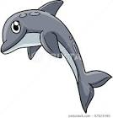  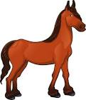 | PE  This half term we are developing our ball skills. Practice throwing, catching and bouncing a ball safely. Start off with a big ball (football etc) and then can you progress to using a small ball (tennis ball etc).  Practice this with a family member and see if they can catch as well as you! | Time  See if you can use/explore time in different ways at home.  - What’s the time Mr Wolf?  - Time games on Topmarks  - Make your own clock. Use a split pin to make your hands move. Ask an adult to move the hands to quarter to/quarter past, half past and to the hour.  Fractions  - Practice folding paper in halves, quarters and thirds. Can you label the fractions?
WANTED  Can you create your own Wanted poster for a famous Pirate? Write some descriptive sentences about what they look like?    Don’t forget to use:  - Capital letters  - Full stops  - Adjectives  - Verbs  - Adverbs | Music  Can you write your own sea shanty about our school?  Here is an example of a Pirate Sea Shanty - https://www.youtube.com/watch?v=ByJZTmI4sLw  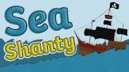 | Cooking!  We are very lucky to have just had our very own edible garden built at Oakfield. Can you plant some seeds, watch them grow and turn your produce into a healthy meal?  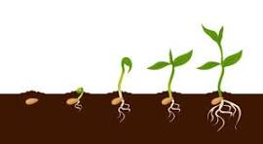  Don’t forget to send us lots of pictures of the progress of your seeds! | Time Tables - Counting in 2’s, 3’s 5’s and 10’s  This half term we will be focusing on developing pupils’ times tables skills. We will be learning how to answer worded problems and finding the answers using our times tables.  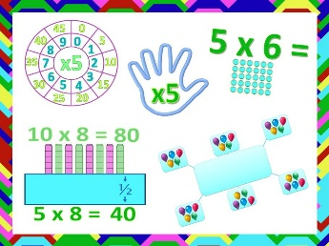  -Can you write your times tables out in order?  -Can you ask an adult to say a times table and then draw groups to show your answer?
Cymraeg  Practice naming food in Welsh and asking your family members what they do and don’t like to eat (see school website for further details)  Beth wyt ti’n bwyta? (What do you eat?)  Dw i’n bwyta… (I eat…)  Dw i’n hoffi bwyta… (I like to eat…)  Dw i’n ddim yn hoffie bwyta… (I do not like to eat…) | Water, Puddles and Ponds  Life on Earth (Summer Term 1)    Here is your homework menu, there are lots of different homework activities to choose from. Please complete the activities that are coloured grey and at least one 3-star activity. Over the Half Term you need to aim to earn 20 stars, stars mean Dojo points! If you earn 20 stars by the end of the half term you will be entered into a prize draw! |  | Topmarks –    Can you practice your money, times tables, time and basic numbers using different games?
Science and Technology |  | Humanities
Purple Mash  Can you go on 2 Create a Story and create your own story of a Pirate adventure?  Make sure you:  - Capital Letters  - Finger spaces  - Sound and stretch the words. |   Practice logging into:  Purple Mash  Numbots    TTRockstars  HWB  If you need a reminder of your child’s details please let your child’s class teacher know. | Continued – Hinuism  This half term we will be continuing to look at an Hindu place of worship.  - Can you draw a picture of a Hindu temple?  - Discuss the similarities and differences between a Hindu place of worship and other places of worship. | History  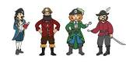  Can you research a famous Pirate from history and create a factfile on your chosen Pirate?

