Language, Literacy and Communication  LLC | Expressive Arts | Health and Well-Being | Maths and Numeracy  TTRockStars  Practice logging into TTRockstars to practice your times table knowledge and Numbots.
  Practise your spellings by completing: look, read, say, cover, write, check.  Let’s see who will get full marks this term!  Why not test someone in your family on the words? Be the teacher! | Expressive Arts – Creative  Can you construct your own version of Cardiff Castle/Millenium Stadium/Senedd etc using junk materials? If you want to draw/paint any of these instead we will leave the choice up to you!  Send us a picture of your creation! | 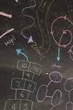  PE  This half term we are developing our balance skills. Can you create your own circuit in your street or house and add in different movements?  -Balance along a line  -Frog jump  -hopscotch etc | Money  See if you can use/explore money in different ways at home.  -Ask a family member what coins do they have in their purse or wallet and count up their total.  -Use coins to pay for items in a shop.    -Coin rubbings – Can you make your own coins using rubbings?
Visit some of Cardiff’s Famous Landmarks/Locations  -Take some photos of what you find on your walk/drive around Cardiff. What is your favourite place?  -Cardiff Castle  -National Museum of Cardiff  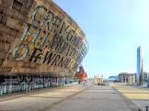  -St Fagan’s National Museum of History  -Cardiff Bay  -Wales Millennium Centre  -Principality Stadium  -Bute Park  -Roath Park | Music  Listen to traditional Welsh music (folk). Can you learn a traditional Welsh dance?  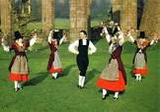    Listen to the Welsh National Anthem! | Cooking!  Can you make some traditional Welsh food e.g. Cawl or Welsh Cakes or use some leeks to make your own recipe!    Don’t forget to send us a picture of your creature. | Time Tables - Counting in 2’s, 3’s 5’s and 10’s  This half term we will be focusing on developing pupils times tables skills. We will be learning how to answer worded problems and finding the answers using our times tables.  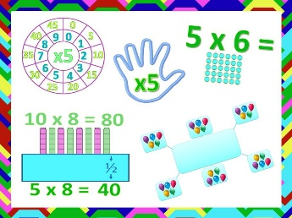  -Can you write your times tables out in order?  -Can you ask an adult to say a times table and then draw groups to show your answer?
Cymraeg  Ask someone in your family 3 questions in Welsh. Can you include some familiar phrases that we have practiced this half term.  Sut wyt ti? (How are you?)  Pwy wyt ti? (Who are you?)  Sut mae’r tywydd heddiw? (What’s the weather like today/)  Beth sy’n bod? (What’s the matter?)  Beth wyt ti’n hoffi? (What would you like?)  Beth wyt ti’n gwisgo? (What are you wearing?) | Cymru am Byth  Cwl Caerdydd (Spring Term 1)    Here is your homework menu, there are lots of different homework activities to choose from. Please complete the activities that are coloured grey and at least one 3-star activity. Over the Half Term you need to aim to earn 20 stars, stars mean Dojo points! If you earn 20 stars by the end of the half term you will be entered into a prize draw! |  | Topmarks –    Can you practice your money skills, times tables and basic numbers u sing different games?
Science and Technology |  | Humanities
Purple Mash  Complete your tasks set on Purple Mash and submit them to your teacher.  Make sure you:  - Capital Letters  - Finger spaces  - Sound and stretch the words. |   Practice logging into:  Purple Mash  Numbots    TTRockstars  HWB  If you need a reminder of your child’s details please let your child’s class teacher know. | Continued - Christianity  This half term we will be continuing to look at a Christian place of worship.  We will investigate the places of worship in our local area. | Explore your locality  Use Google Earth to find your hoouse.  -Can you find any other places you recognise in your local community.    -Can you use street view and find your way to your house?

