Language, Literacy and Communication  LLC | Expressive Arts | Health and Well-Being | Maths and Numeracy
  Practise your spellings by completing: look, read, say, cover, write, check.  Let’s see who will get full marks this term!  Why not test someone in your family on the words? Be the teacher! | Vegetable Art  Create a ‘vegetable person’ using real vegetables or pictures of vegetables.  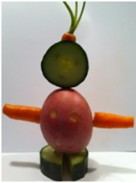 | Pupil Voice – Isaac – Miss Rafferty’s Class  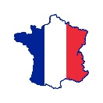  During our Year 2 pupil voice discussion we had a request for a school trip to Paris. Unfortunately, we are unable to do this so the Year 2 pupils decided they would like to try and walk the 889,498 steps from London to Paris.  We would like the whole family involved send in your weekly steps to your child’s class teacher. We would like to get there before half term. If we achieve our goal we will have a French themed day in school. | Practice Counting in 2’s, 5’s and 10’s.  Can you do this in rainbow colours? Can you colour the even numbers in one colour and odd numbers in another?  Practice logging into TTRockstars to practice your times table knowledge and Numbots to practice our basic number skills e.g. addition, subtraction, fact families etc.  Log in details will be sent home with your child’s reading book on Friday.
Can you make a list of healthy foods and unhealthy foods?  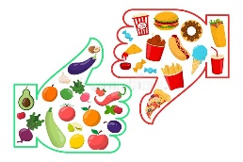  Which is your favourite and why? |   Sports Personality  Draw a picture and write about your favourite sports personality. Don’t forget to send us a picture. Bonus Tocynnau Ty’s if you can write them a letter about yourself. | Cooking!  Cook a healthy meal with your family and share pictures with us on Class Dojo. | 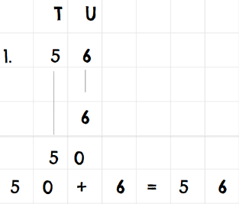  Partitioning  Can you partition a 2/3/4-digit number into Thousands/ Hundreds/Tens and units?
  Do you have any books with about the body at home? Could you borrow one from a library? We would love to hear you reading one to share with us in school. | Mind, Body and Soul  Heathy Living (Autumn Term 1)    Here is your homework menu, there are lots of different homework activities to choose from. Please complete the activities that are coloured grey and at least one 3-star activity. Over the Half Term you need to aim to earn 20 stars, stars mean Dojo points! If you earn 20 stars by the end of the half term you will be entered into a prize draw! |  | Addition and Subtraction  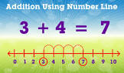  Can you practice adding a 2 digit number to a 1 digit number using a number line?
Science and Technology |  | Humanities
Can you grow your own food? In a vegetable patch or in a plant pot? Some of the easiest things to grow include wild strawberries, cherry tomatoes, radishes, runner beans, lettuce, chives, carrots and potatoes. |   Learn how to log into:  Purple Mash  Numbots    TTRockstars  HWB  Your child will be sent home with all log in details shortly. | St Mellons/Cardiff  Walk around your local area and take picture of what you find. We would love to see what places you visit. Don’t forget to send them to us on Class Dojo.  How many steps from your house to school? – Don’t forget to send us your steps! | Christianity  This half term we will be looking at a Chirtian place of worship.  What do you know about chirstianity?  Can draw a picture of a church and label the different parts?

