Fighting Fit - Brilliant Bodies– Autumn 1
Here is your homework menu, there are lots of different homework activities to choose from.
Don’t forget to let us know what you do using Class Dojo. We do enjoy seeing what you get up to at home and with your families too!
Practise your spellings by completing: look, read, say, cover, write, check. | Sometimes we can get a little bit cross or upset. List the ways that you can help yourself to calm down. For example; Do some mindfulness breathing. | 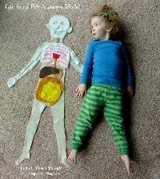  Create your own human body model and label the main organs | Let’s get your times tables learnt in Year 3!! Log onto TT Rockstars and have some fun every day. Let us know how you do via Dojo.
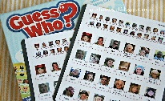  Write a description of your favourite character from a book, film or programme. Don’t tell us who it is and see if we can guess from your description.  This Photo by Unknown Author is licensed under CC BY-NC |   Create your own exercise routine and ask someone to video it and share it with us. Alternatively, you could send us a video of yourself playing a sport or enjoy spending time outside. | Ask someone in your house to test you on some maths. It could be adding and subtracting, timestables or number bonds to 10/20 or even 30! Ask them to let us know how you get on! | 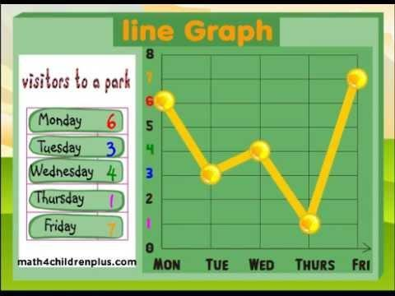  Take your resting heart beat, then do a minute of jogging and take it again, try star jumps and gentle walking. Now plot the results.
  Teach someone in your family some Welsh phrases – Sut wyt ti? Dw I’n hapus.  Pwy wyt ti? Sam ydw i. | Play spelling games on www.kidspell.com, every night of the week. | Choose a book to read, write a review thinking about what you liked/didn’t like and why. Identify the author, genre and draw a picture from the story. | This term we will be learning our 2, 5, 10 timetables. Practice counting in these multiples. Do you know the divisions? Test a family member!
  Read your reading book every night of the week. Log onto Giglets and enjoy a read! | Choose a mindfulness activity to carry out. It could be colouring, yoga, taking a walk or deep breathing.  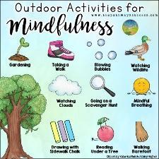 | Log into HWB and create a presentation on a topic of your choice and present it in class.   | Cook a healthy meal with Mum or Dad. Make sure the plate is balanced. Send us a picture on Dojo. 

