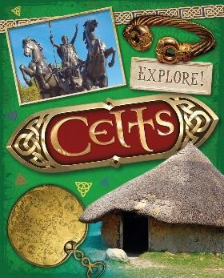
Cwl Celts – Autumn 2
Here is your exciting homework menu, there are lots of different homework activities to choose from.
Lots of Tocyn Ty’s to be rewarded for working at home and learning even more!! Pob Lwc!! Good luck.
Practise your spellings by completing: look, read, say, cover, write, check.  Put your week’s spellings into silly sentences, using a conjunction in each: when, if, that, because, and, but, so, yet. | Log in to Giglets and read the book that has been assigned to you. Read it to yourself or a family member and discuss what the book is about. | 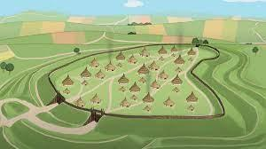  Create your own hillfort. Either a picture or a model of one. | Who was Boudicca? She led a large Celtic army. Can you find out some more facts about her? Good luck!  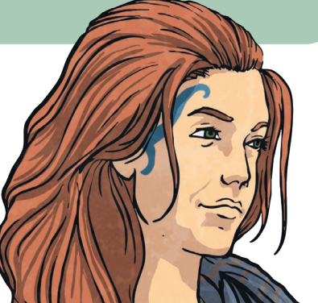
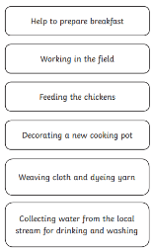  Can you write a diary entry as if you are a Celt? What would you be doing? Where would you have slept that night? Use adjectives to describe. | 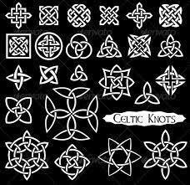  Create your own Celtic knot - draw it, use materials. We can’t wait to see what you make! | 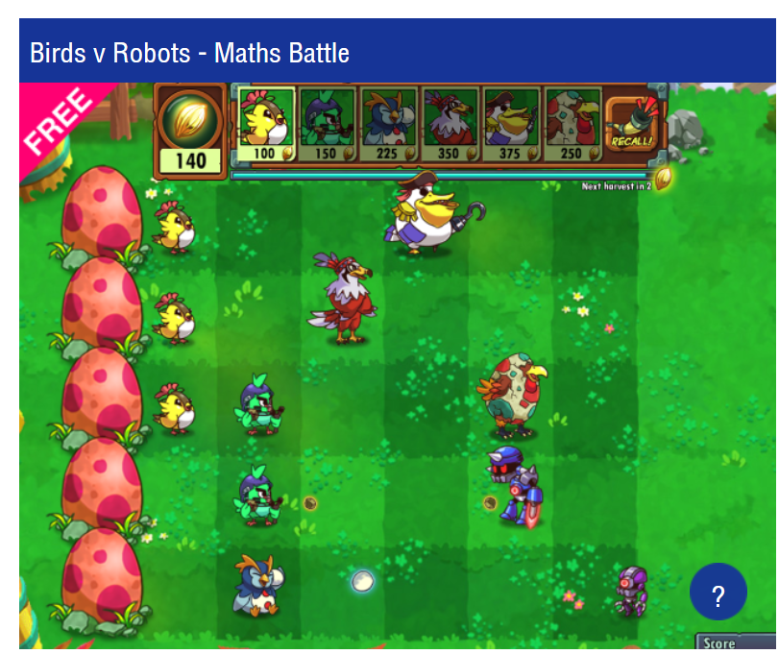  Visit this website to help develop your Maths skills:  https://mathsframe.co.uk/en/resources/category/22/most-popular | 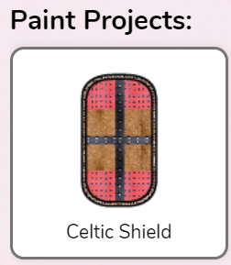  Log on to Purplemash and complete the 2Do task. Design a Celtic shield  https://www.purplemash.com/sch/oakfield-cf3#/
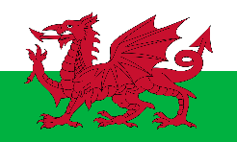  Ask someone in your family 5 questions in Welsh. | Can you research what the Celts ate and drank? Write or draw about it.  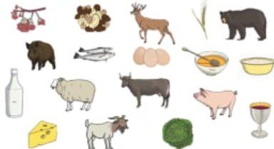 | Choose a book to read, write a review thinking about what you liked/didn’t like and why. Identify the author, genre and draw a picture from the story. |   This term we will be developing our knowledge of our 2, 3, 4, 5 and 10 times tables Use TTRS to practise improving your times table skills.  https://ttrockstars.com/
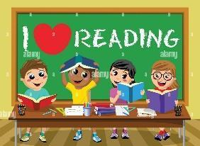  Read your reading book every night of the week. | 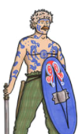  Draw a Celtic warrior and label it. | Log into HWB and create a presentation on Cwl Celts to present in class. | Using playdough, foil or a material of your choice to make your own torc. 

