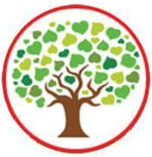
Blwyddyn Tri - Cwl Celts (Spring 2)
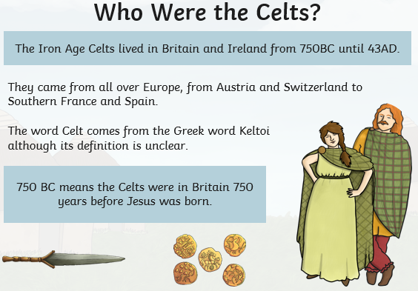
This half term we will be learning all about the Celts focusing on the ‘Humanities’ Area of Learning.
Therefore, we will be:
Researching and expanding our knowledge of the Celts.
Looking at the history of where the Celts came from and a timeline of their events.
Learning about how the Celts lived and comparing it to life now.
Building our own Roundhouses.
Finding out about hillforts and why they were so important.
Learning about the different Celtic Tribes
Creating our own tribal pattern.
Virtual workshop from St. Fagans.
Pupil Voice – A landing day ‘We are Celts’. At the end of the topic we will be dressing up as a Celt and carrying out fun activities as if we are the Oakfield Tribe from 25AD.

Numeracy –
We will be focusing on Length, Area and Capacity.
2D and 3D shapes and their properties.
Learning about symmetry and creating symmetrical patterns.
We will also be reviewing our number skills by reviewing some of the following skills:
understanding place value with developing confidence when multiplying and dividing by 10/100.
Adding and subtracting in columns.
Multiplying and dividing by 2,3,4,5 and 10. Challenge multiplying by 6.

Literacy – This term we will be working on our reading skills including phonics and high frequency words. Please help your child on a weekly basis, they will continue to come home with a book including their words to learn that week.
Our extended writing tasks will include: story retell, non-chronological reports and diary entries.
Our Welsh this term is ‘Ar Y Penwythnos – On the Weekend’
`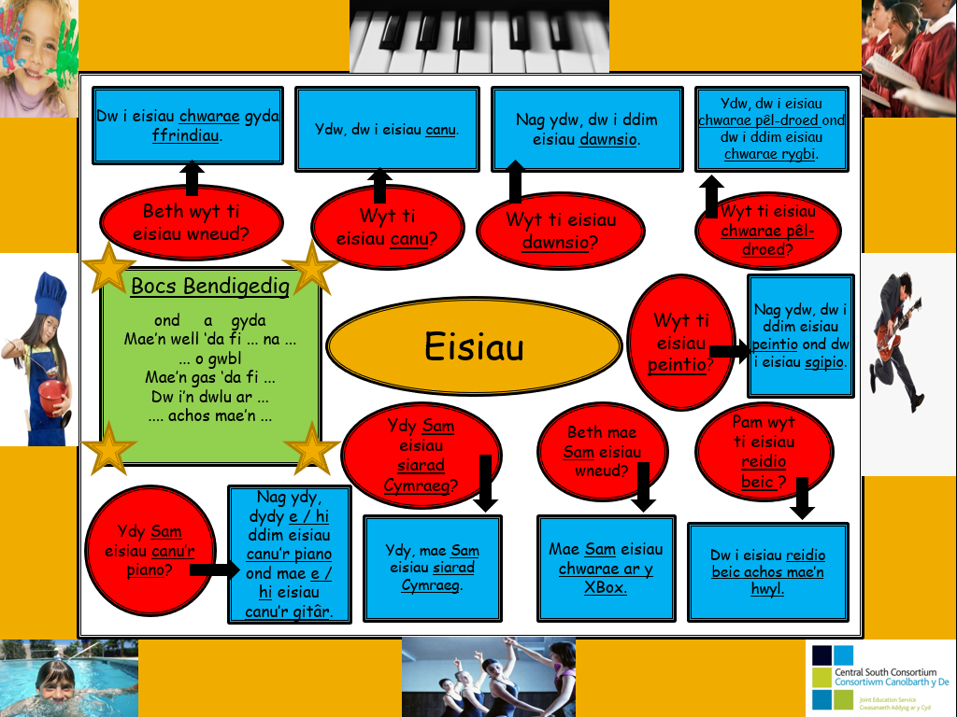Our ICT lessons will focus on ‘Data, Data Everywhere!’. The children will be creating their own database using Google Spreadsheets on Google Classroom.

