
Fantastic Film & TV – Spring 1
Here is your homework menu, there are lots of different homework activities to choose from.
You MUST complete the activities that are coloured grey and at least one 4-star activity.
Over the Half Term you need to aim to earn 20 stars, stars mean Dojo points! If you earn 20 stars by the end of the half term you will be entered into a prize draw!
Can you tie you own shoe laces? If not, can you try and learn how to do it. If you don’t have shoes laces find someone who can!! | Put your week’s spellings into silly sentences, using a conjunction in each: when, if, that, because, and, but, so, yet. | 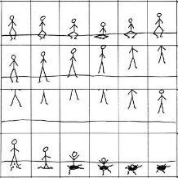  Create your own flipbook | 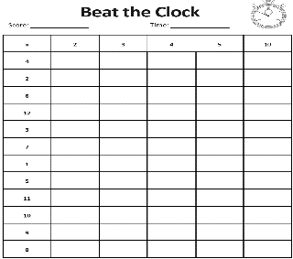  Beat the clock. How long does it you to fill in the chart? Can you beat your time?
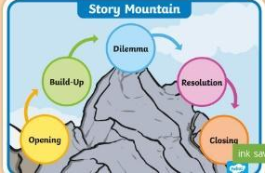  Can you write a story including an opening, build-up, dilemma, resolution and ending? Choose to write it on paper, record it or type it on Classroom. |   Create your own Stop Animation movie and post it on Dojo or Classroom. Download the StopMotion App for free. | Use TTRockstars to help you practise and improve your times tables. |   At bedtime or in your free time log onto Giglets and read one of the books that have been assigned to you.
  Ask someone in your family 5 questions in Welsh. | Play spelling games on www.kidspell.com, every night of the week. | Choose a book to read, write a review thinking about what you liked/didn’t like and why. Identify the author, genre and draw a picture from the story. | This term we will be developing our knowledge of the 2, 3, 4, 5, 10 timetables. Practice counting in these multiples.
  Read your reading book every night of the week. |   Write a New Year’s Resolution and say why it is important to you. | Log into HWB and create a presentation on Mike Young – an animator from Cardiff. | Watch an animated film of your choice. Can you identify the opening, build-up, dilemma, resolution and ending? What worked well/what could be improved?

