Blwyddyn Tri - Amazing Animation (Spring 1)
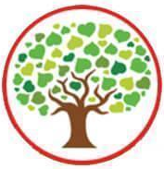
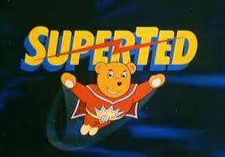
This half term we will be learning all about how the animation is made, focusing on the ‘Expressive Arts’ Area of Learning.

We have so many exciting projects ahead in our new topic:
- Learning how to make flip books and make our own
- Writing our own playscripts as a group
- Designing our own film set
- Using Ipads and Zu3d app to make our stop-motion movies!
- Hold an awards ceremony to celebrate the movies that are created!
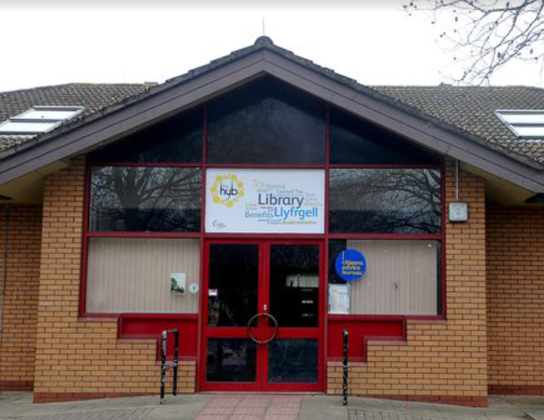
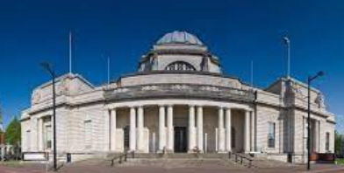
*** Visiting St Mellons Hwb***
AND
*** Cardiff Museum of Wales ***

Pupil Voice – We will be finding out the answers to our BIG QUESTIONS: How can we make characters move in a movie? What skills will we need to work well as a group to make a short movie?

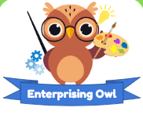

Numeracy – During this term we will be covering concepts which include inverse operations, using arrays and making decisions. There will also be a focus on our timetables, in particular the 2,3,4,5 and 10 times tables where we will be multiplying and dividing by these numbers. Practising our times tables using TTRockstars will really help us with our work.

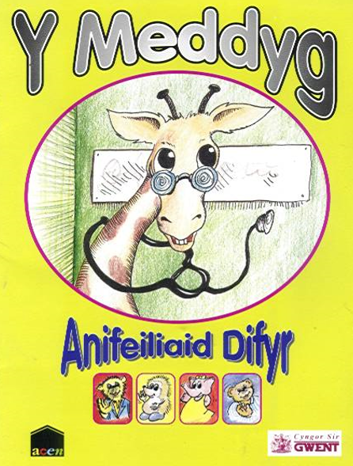
Literacy – This term we will be writing a recount of our trip to the St Mellons Hwb. We will be researching Mike Young, the creator of SuperTed and using what we have learnt to create our own play script. Please continue to support your child with their weekly spellings and reading book. Diolch!

Our Welsh topic this half term is ‘Fi a Fy Ffrindiau (Me and My Friends)’
Have a read of this super book Y Meddyg.ppt
We can’t wait for another fantastic half term with Year 3 pupils giving 100% effort every day!

