Super Scientists – Reduce, Reuse, Recycle
Here is your homework menu, there are lots of different homework activities to choose from.
Don’t forget to let us know what you do using Class Dojo. We do enjoy seeing what you get up to at home and with your families too!
Practise your spellings by completing: look, read, say, cover, write, check.  Put them into silly sentences and share with someone in your family. | Don’t throw away the cardboard boxes and yogurt containers! Build a robot with these materials.  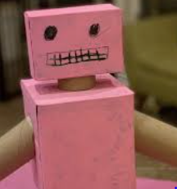 | Find out more about recycling by playing these fun games:  Welcome to Recycle City | Recycle City | U.S. EPA | Help the Octonauts to save the planet and help the environment: Octonauts Ocean Adventures (bbc.co.uk)
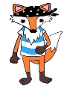  Using your fraction knowledge join Fantastic Fox in creating your own Fraction Monster  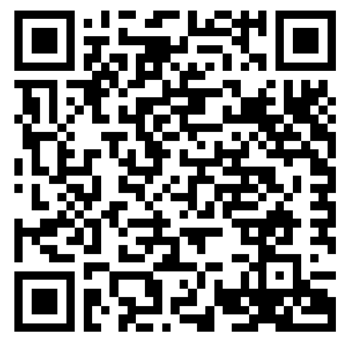  Use the QR code for more ideas.  Share you creations with us on Dojo. | We know how much you enjoy baking. So have a go at making some gingerbread people – ask an adult for some help. An easy recipe is here: Gingerbread men recipe - BBC Food  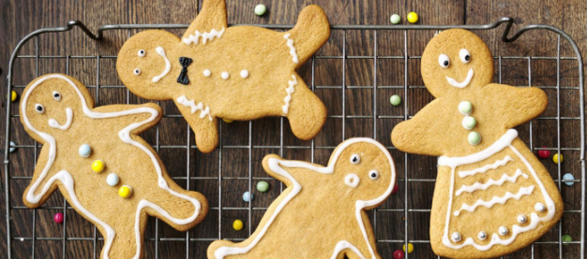 | Make your own artsy paper that has wildflower seeds in it! Use coloured markers to paint a design or message on it. Give it to someone special to plant in a pot or in the ground. Keep it wet and warm, and it will "recycle" into something far better than old, used paper. | Design your own logo for recycling. Maybe use some recycled items from around your home?  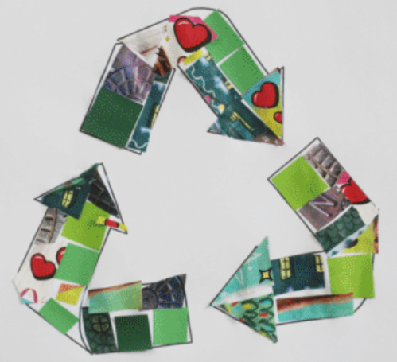  Pob lwc!
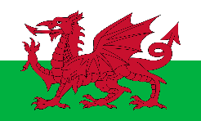  Teach someone in your family some Welsh phrases – Sut wyt ti? Dw I’n hapus.  Pwy wyt ti? Sam ydw i. | Play spelling games on www.kidspell.com, every night of the week.  Da iawn pawb! | Plan and prepare a simple picnic for you and your family to go out and enjoy. If you can’t get real food, design some and pretend! Gwych! | Make your own binoculars. Use this video to help - How to make binoculars out of toilet rolls - BBC Tiny Happy People Take them outside and see what you can see. Take some pics to send to us!
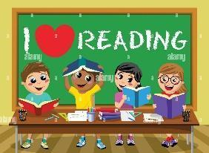  Read your reading book every night of the week. Log onto Giglets and enjoy a read! | Become Weather Watchers. Look at the clouds, Relax. If you want to find out more about clouds look here : Home - BBC Weather Watchers  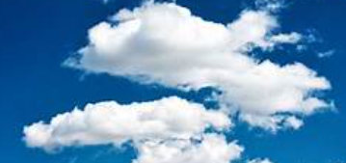 | Log into HWB and create a presentation on a topic of your choice and present it in class.   | Become messy monsters! Take some old pots, pans and dishes outside. Make a mud pie, stir in flowers and water and more! Send us a picture on Dojo.  

