Curriculum News

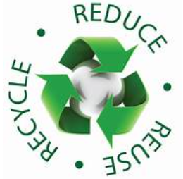
Summer 1

Welcome back to a fun-filled Summer Term in Year 3.

We are all going to become SUPER SCIENTISTS and explore the world around us and how we make it a better place!

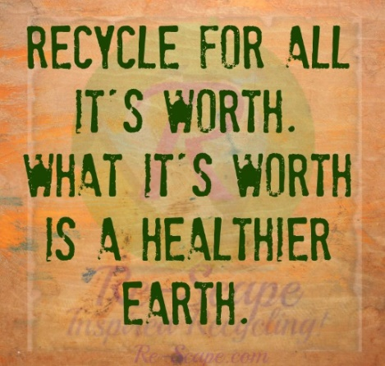


Home-School Communication

- We will continue to use Class Dojo to share work and messages. We are able to respond to messages between 8.30am - 4pm Monday to Friday. We really enjoy hearing about what you do outside of school and any achievements you have made, sporting, musical, anything!
- I
- D
- E
- Our Class Page on the school website is regularly updated with information, please visit the website regularly.
- S
- M
- We also share messages on Twitter and via the School App’.

Pupils will be leading their learning using Pupil Voice opportunities, telling us the types of lessons and activities they would like to take place as part of our theme this half term! Our launch day for the topic will be Wednesday 10th April. It will be a fun way to start our topic!
We like to hear from YOU too about what you think your child could learn about! We value your opinions and support as always!

LLC Opportunities:  - Poetry writing about the wonderful locality and planet Earth  - Researching what we can do to improve and protect the environment  - Write a letter to local MP about plastic pollution  - Retelling the story of ‘The Tale of a Toothbrush’  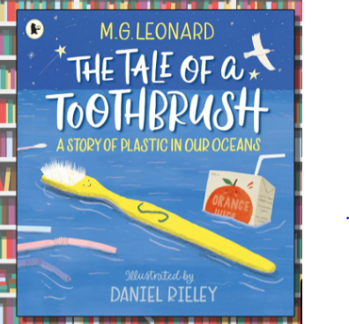 | Numeracy Opportunities:  - A tally chart to show the types of litter found on our litter pick  - Diagrams to reflect the issues of pollution  - Investigate the weight of rubbish from the average home  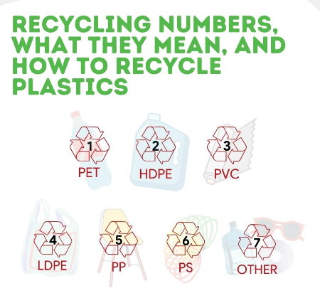
An exciting, immersive and thought-provoking curriculum:
- Design posters to encourage others to reduce, reuse and recycle
- Explore the recycling process – where does the rubbish go?
- Investigate pollution in the ocean
- Identify and promote water saving tips
- Find out how long items take to decompose. Did you know it takes up to 2 years for orange peel to decompose?



