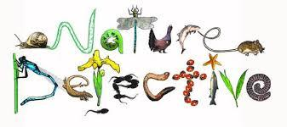
Nature Detectives – Summer 2
Here is your homework menu, there are lots of different homework activities to choose from.
You MUST complete the activities that are coloured grey and at least one 4-star activity.
Over the Half Term you need to aim to earn 20 stars, stars mean Dojo points! If you earn 20 stars by the end of the half term you will be entered into a prize draw!
Practise your spellings by completing: look, read, say, cover, write, check. | Put your week’s spellings into silly sentences, using a conjunction in each: when, if, that, because, and, but, so, yet. Plus also remember to use adjective, nouns and adverbs |   Write a persuasive letter explaining why people should buy Fairtrade items. | Create your own PowerPoint about the journey of certain food for example a banana – from being grown to arriving in the supermarket.  Look at the information on Google classroom to help you.
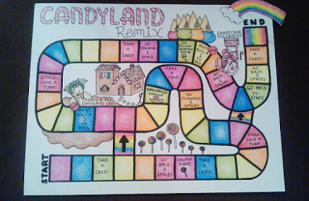  Create your own Fairtrade board game. | Carry out some research about Fairtrade and then design your own Fairtrade logo. | 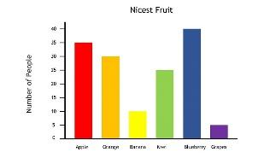  Devise a question and ask your family members, collect the data and present it as a bar graph. | 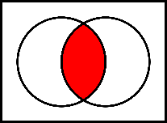  Create a Venn diagram using your own criteria and then complete it.
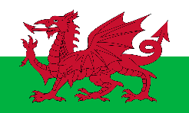  Ask someone in your family 5 questions in Welsh. | Play spelling games on www.kidspell.com, every night of the week. | Choose a book to read, write a review thinking about what you liked/didn’t like and why. Identify the author, genre and draw a picture from the story. | Practice your times tables on TT Rockstars  
  Read your reading book or books on Giglets every night of the week. | 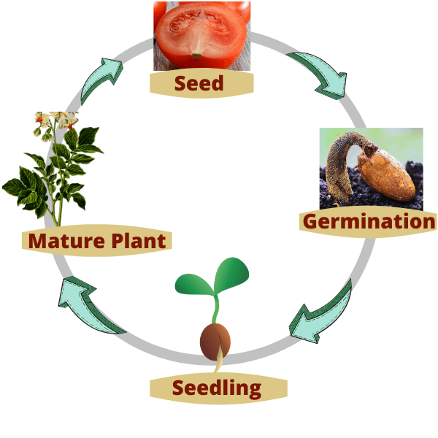Draw a life cycle of a plant. | Log into Purplemash and create your own Mashcam. | Go on a nature hunt and send us some pictures of what you find. 

