Curriculum News – Year 3
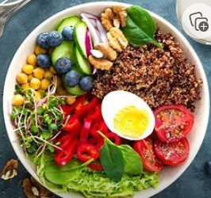
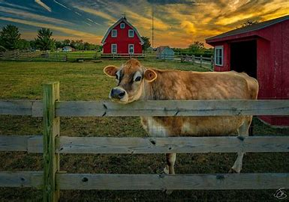
Theme – ‘From Farm to Fork’

Our launch day:
Designing and creating fruit kebabs
Discussing why fruit and vegetables need certain climates to grow
Learning about health and safety in kitchens.

We will be asking some big questions……

Where does our food come from? | What is Fairtrade all about? | How many countries and continents are there?
What makes some countries hotter than others? | Do any religions not eat meat and why? | How quickly can cress grow and under what conditions?
Home-School Communication

- We will continue to use Class Dojo to share work and messages. We are able to respond to messages between 8.30am - 4pm Monday to Friday. We really enjoy hearing about what you do outside of school and any achievements you have made, sporting, musical, anything!
- I
- D
- E
- Our Class Page on the school website is regularly updated with information, please visit the website regularly.
- S
- M
- We also share messages on Twitter and via the School App’.

Following our Pupil Voice session on Monday, we will also add the children’s ideas for their learning journey this term.
We like to hear from YOU too about what you think your child could learn about! We value your opinions and support as always.
We will also be:
- Learning the Welsh words for animals and acting out conversations
- Studying Van Gough - Still Life with Apples, Pears, Lemons and Grapes
- Creating new styles for familiar animals
- Making shadow puppets and act out life on a farm
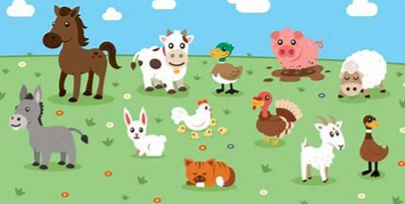
Our Landing Day: Visit to Meadows Farm

