
Nutrition Mission – Autumn 1
Here is your homework menu, there are lots of different homework activities to choose from.
You MUST complete the activities that are coloured grey and at least one 4-star activity.
Over the Half Term you need to aim to earn 20 stars, stars mean Dojo points! If you earn 20 stars by the end of the half term you will be entered into a prize draw!
Practise your spellings by completing: look, read, say, cover, write, check. | Put your week’s spellings into silly sentences, using a conjunction in each: when, if, that, because, and, but, so, yet. | Create a meal plan for a day  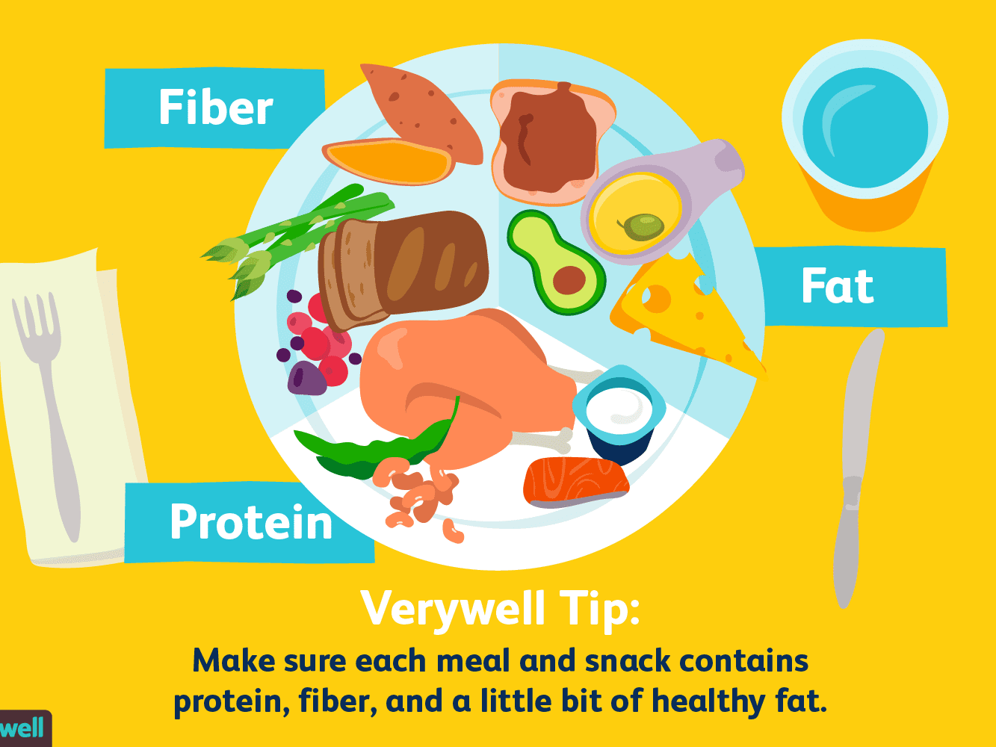 | Play on Active Learn every night of the week and complete the game to improve your world.
Make a pitta/wrap pizza and write a set of instructions on how to make it.  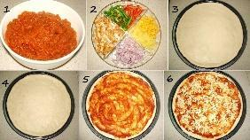 | Choose a country to research, find out what food they eat, grow and enjoy.  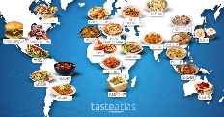 | Practice addition and subtraction in columns. Challenge: borrow and carry. | Go over your 3, 4, 8 timetables. We will be moving onto our 6 times table next.
  Ask someone in your family 5 questions in Welsh. | Play spelling games on www.kidspell.com, every night of the week. | Choose a book to read, write a review thinking about what you liked/didn’t like and why. Identify the author, genre and draw a picture from the story. | 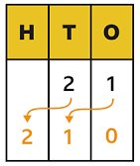  This term we will be revising multiplying and dividing by 10 and 100. Can you roll a dice twice to make a 2 digit number and then multiply it by 10/100 and divide it by 10/100?
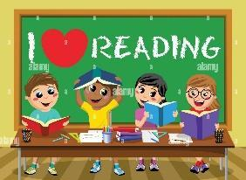  Read your reading book every night of the week. | 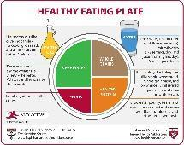  Draw a balanced meal and label the food groups. | Log into HWB and create a presentation on a topic of your choice to present in class. |   Use your Pupil Voice to write down what you would like to develop and learn about this year and why.

