08.09.23 Curriculum News ^{AUTUMN 1}
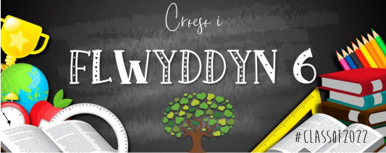
#Classof23

Flwyddyn 4

Welcome to Y4!
The Year 4 teachers are Mrs. Hoskins & Mrs Lovett (4HL) and Miss. Buckland (4B) with extra support from Mrs O’Hanlon, Mrs Morgan, Mrs Lamb, Miss Tansey, Mr Thomas, Mr Johnson & Mrs Rowland.
We are very much looking forward to our first term together. The children have made an incredible first impression. Remember to continue working hard and be the best you can be - let’s reach for the stars! Pob lwc!
Home-School Communication
- We use Class Dojo to share work and messages. If you have any questions please feel free to ask.
- We will be using Google Classroom to support our learning in class. We will also use this to support
Home Learning. We will be adding children’s ‘DIgital Passports’ to their Class Dojo portfolios so they
- S
- L
are able to use all of their log-in details at home.
- I
- D
- E
- Our Class Page is regularly updated with information, please visit the website regularly.
- S
- M
- We also share messages on Twitter and via the School App’.
A
N
I
A
.
C
O
M
08.09.23
Curriculum News ^{AUTUMN 1}
LITERACY, LANGUAGE & MATHS & NUMERACY COMMUNICATION
PE - Wednesday
This term we will be focusing on developing our basic skills in reading and writing. We will be reading and interpreting a variety of texts, and producing extended writing as part of our lessons, in a range of genres. We will be focusing on Instructional writing and Recount writing this half term.

We have high expectations for handwriting and presentation, and we will be developing these throughout the term. We will be working on our speaking and listening skills through a range of oracy activities.

There will be a big focus on developing our core number and place value skills during Autumn Term. We will also be using our ‘Big Maths Online’ tool that the children are fully engaged in!
Maths homework will be provided online, either through Google Classroom or with pupils accessing TT Rockstars to improve their times tables. Please help to support your child’s progress by practising times-tables and basic number skills at home. We will be recapping on our 3’s, 4’s & 8’s. The new times table we will be learning will be our 6’s.
‘Real PE’ sessions will take place every Wednesday afternoon.

Children will need to wear weather appropriate PE clothing and footwear to school on this day.
Autumn 1 Thrilling Theme

L
I
D
E
S
M
A
N
I
A
.
C
O
M

This half term, our Topic will be ‘Nutrition Mission’. Focusing on Health and Wellbeing. Here are just some of the skills we will be focussing on developing:
I can explain the importance of a balanced diet and nutrition and the impact my choices have on my physical health and well-being. I can plan and prepare basic, nutritious meals.
I can describe the behaviours, conditions and situations that affect my physical health and well-being, and I know how to respond to and/or manage these in order to actively reduce the risk of harm to myself.
I can identify and assess risks, and I can take steps to reduce them.
I can recognise that some decisions I make will have a long-term impact on my life and the lives of others.
I can identify questions that can be investigated scientifically and suggest suitable methods of inquiry.
I can suggest conclusions as a result of carrying out my inquiries.
I can describe some of the relationships, links and connections between a range of societies
Pupils will be leading their learning by completing Pupil Influence to aid planning, telling us the types of lessons and activities they would like to take place as part of our theme this half term!

