


Now Open…
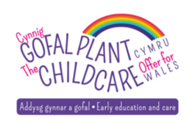

Little People @ Oakfield

We are very excited to be working with Oakfield Primary School in offering the Childcare Offer for Wales. The offer provides 30 hours a week of Government funded early education and childcare for eligible working parents of 3 – 4 year olds (information below).

Little People have been providing high quality childcare that enhances the development, care and education of pre-school children in a safe and stimulating environment in the east of Cardiff for 17 years.

If you require any further information please contact:
02920799396
Carolyn Harris or Donna Thomas –
littlepeopleoakfield@gmail.com


