
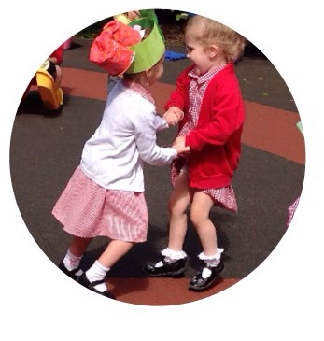
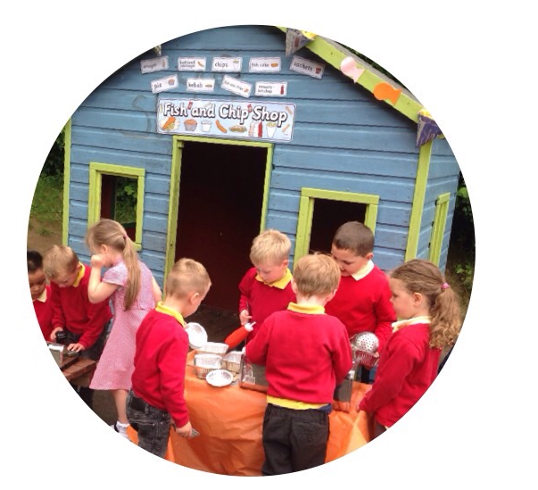
Welcome Booklet

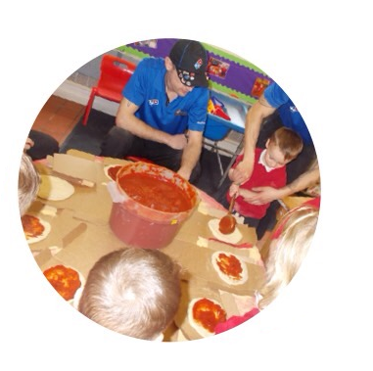

j
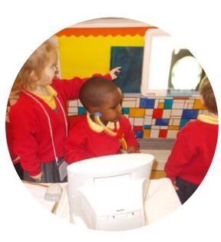
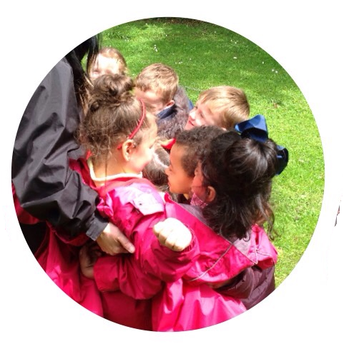
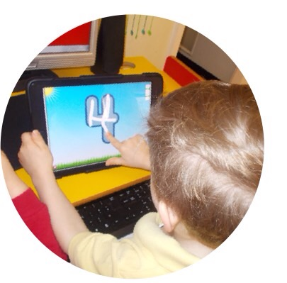
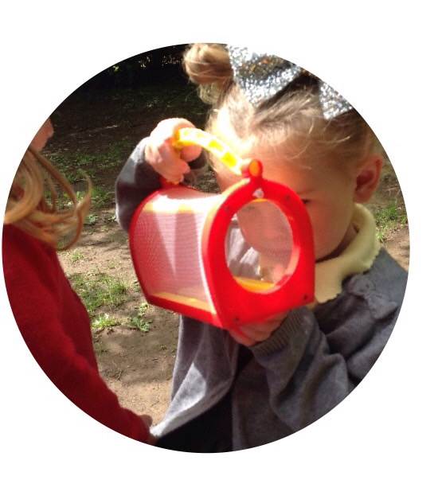
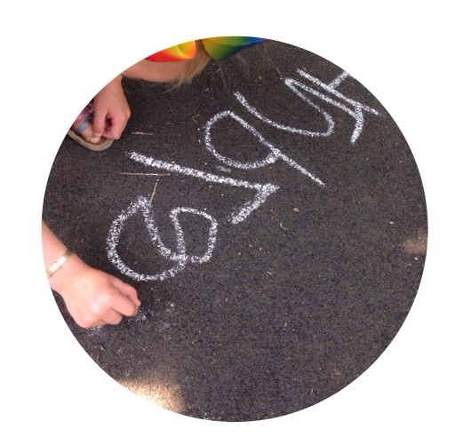
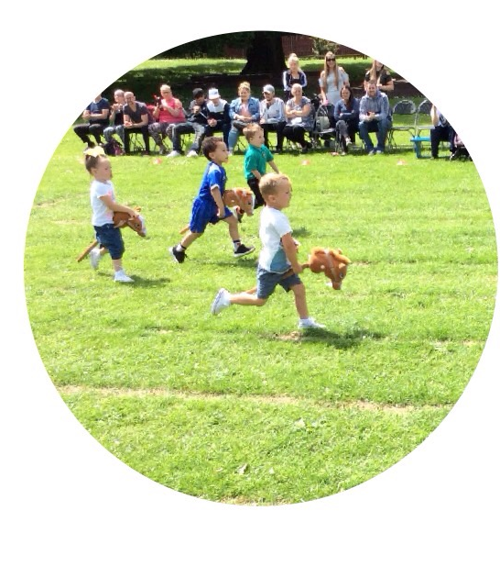

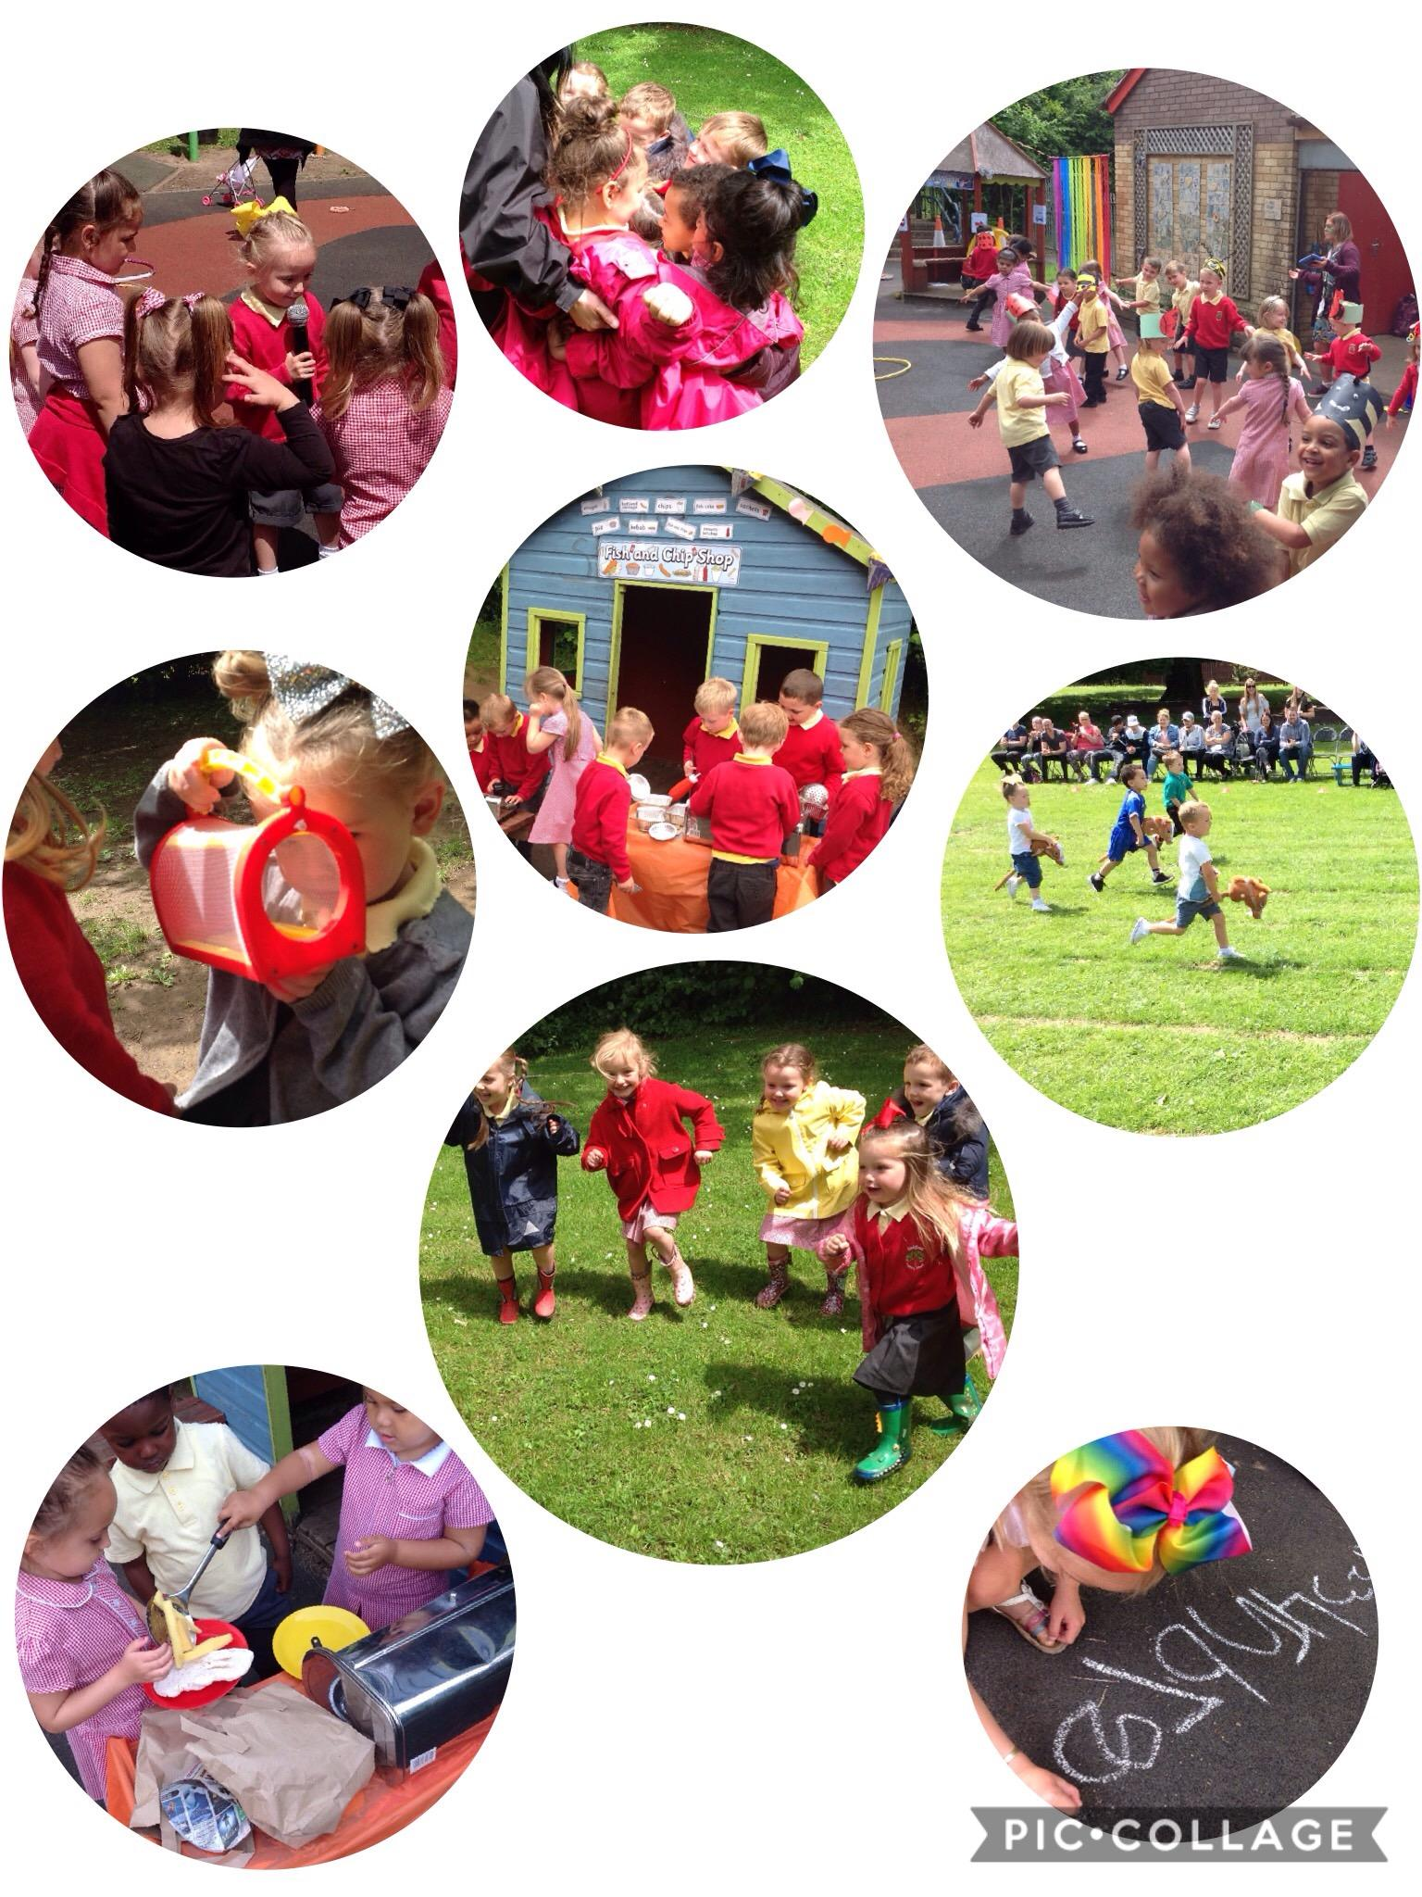


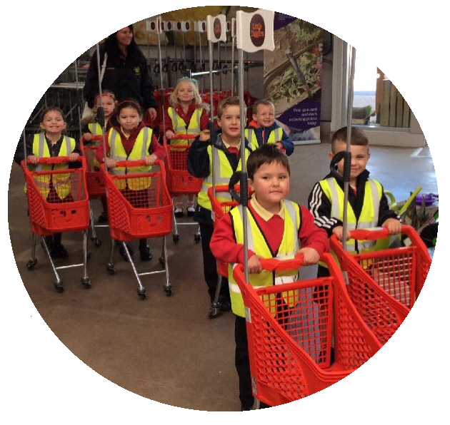
Nursery

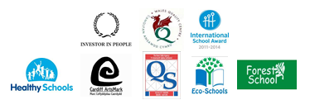

The Governors and Staff would like to welcome your child and your family to our Nursery.

We hope you find the welcome booklet a useful guide for your child’s first experience of school.

Oakfield Primary School
Ferntree Drive, St Mellons, Cardiff, CF3 0AA

Head Teacher: Mr D Harris

Telephone: 029 2079 9396
Nursery Direct Line: 02920 799411

Fax: 029 2079 9414
Website: www.oakfieldprimary.com

Nursery Opening Times
Morning: 9:00am - 11:30am

Afternoon: 12:45pm - 3:15pm



Twitter Handle: @OakfieldCardiff

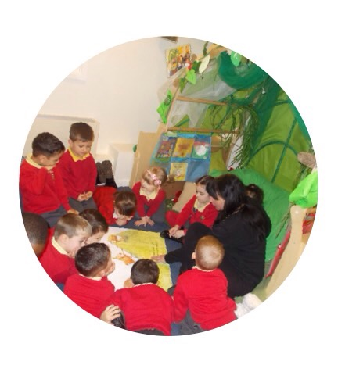

Our Aims
We strive to:

• Provide a happy, safe and secure environment full of love, care and respect for each other.

• Create a stimulating and fun environment with child-centred and adult initiated play which promotes children’s learning and fosters enquiring minds and happy learners.

• Deliver a broad and balanced Early Years Curriculum based on the 6 Areas of Learning outlined in the New Curriculum for Wales

• Work in partnership with parents and value the help and guidance they give to their children.

• Help children to make sense of the world they live in and help them to take a positive role in it.

• Encourage children to make their own decisions and choices.

• Provide an environment rich in language to encourage communication skills.

• Form positive relationships built on mutual trust and respect.

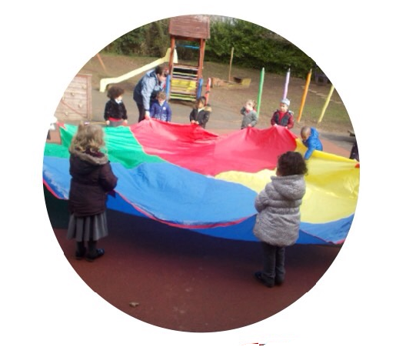

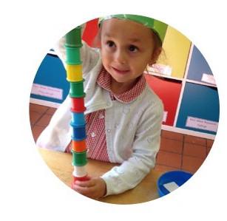

Starting Nursery
Starting nursery is a significant milestone in your child's life. We will do all we can to help them feel welcome, safe and secure. We are aware of the tremendous input that you, as parents, have already made in the education of your child and we look forward to developing a partnership with you in these valuable early years.

Preparing Your Child
Starting nursery is a very exciting time for young children and together we can make it a very happy and rewarding time. Before starting nursery, talk to your child about coming to nursery and about the things they will be doing and the people they will be meeting.
It is important to remember that young children vary tremendously in the way in which they react to new experiences so do allow your child plenty of time to settle into nursery - some children may take longer to settle than others.

Leaving Your Child
When you do leave your child for the first time, it is best to do so for only a short period, building up the time over a few days if necessary. Always make sure that you say "goodbye" to your child and tell them when you will be coming back and what you will be doing whilst you are away.

Starting Nursery
When your child starts nursery you will find that only a few children will start on the same day. By admitting the children a few at a time we find that the children are able to settle quickly and easily into the nursery routine, making the transition from home to nursery as smooth as possible for both children and parents.

Your Child’s First Day
On the first day, you will be asked to come and collect your child 15 minutes early so that you will be the first parent to arrive. New children can sometimes panic if they see other parents arriving and leaving.
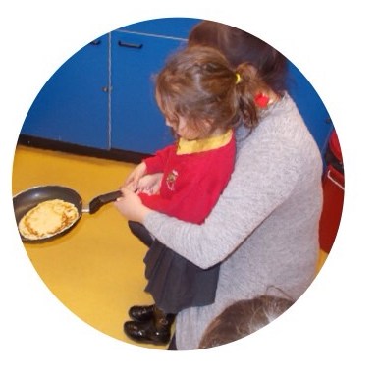

Partnerships with Parents
We want to work closely with you. Good communication between staff and parents enables us to inform each other of relevant matters concerning your child. We appreciate being informed of any change at home that might affect your child and will treat anything you tell us in strict confidence.

Updates and News
We want to inform you about the activities and learning experiences that your child will be taking part in. We update parents using the following:

- Weekly Newsletter (also accessible via our Class Page)
- Our Class Page – accessible via Oakfield Primary School Website www.oakfieldprimary.com
- Weekly updates showcasing the wonderful things we have been doing via Twitter @OakfieldCardiff
- Class Dojo App - invitation will be emailed to parents

Consultations
We hold two Parents' Evenings each year when you will be invited to discuss your child's progress. However, there is no need to wait for these if you have questions or concerns. We want you to feel welcome at the nursery and will always have time for you.

Oakfield Parent, Friend & Teacher Association (PTA)
We have an active PTA who organise events throughout the academic year with the whole purpose of raising money for the school and children. We are always looking for new members so if you would like to be involved then please speak to a member of staff.

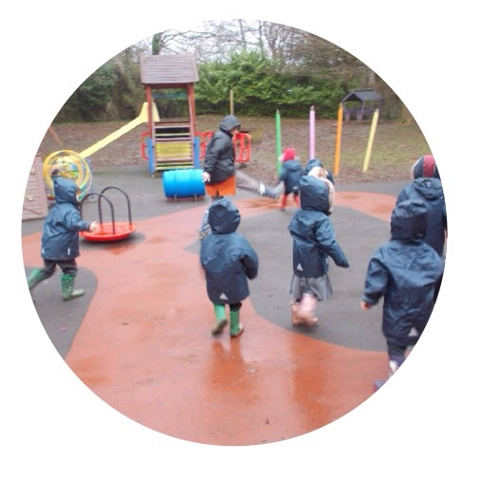

How You Can Help
Bringing and Collecting Your Child
• Oakfield Nursery is accessible via Meadowlark close. Please do not walk through the staff car park.
• Please ensure the safety of all children by closing all gates and doors after you have passed through them.
• Children must be brought and collected by a person over the age of 16 years.
• Please tell us if someone different will be collecting your child or if you are going to be late for any reason. Also let us know if you need to collect your child early.
• Please ensure that your child is brought to Nursery on time. We plan a busy session and wouldn’t want anybody to miss out on valuable learning and experiences.
• We would be grateful if you would ensure that your child is collected on time at the end of each session as children can get upset if they are always left until last.

Absences and Illness
• Please inform us of any change of address or contact numbers so that we can get in touch with you if your child becomes unwell.
• If your child is absent please contact the school (see page 2) or send a written note as soon as possible. We appreciate being contacted via the Nursery direct line as we are able to adjust our register accordingly.
• If your child has had sickness or diarrhoea please keep them at home for 48 hours after their last period of sickness.
• Please inform us if your child is going on holiday during term time.


Clothing and Personal Items
• We are proud of our uniform and crest and therefore expect children to be wearing school uniform at all times.
• Please arrange for your child to be sensibly and comfortably dressed in clothes that they can cope with when going to the toilet, playing in the water or changing for outdoor play. It is important that they are able to develop independence.
• Ensure that your child's coat and hat, for example are named and that they do bring a coat on cooler days as we value our outdoor learning.
• We discourage jewellery as it can get caught or lost.
• Every child will have his or her own coat peg with name and picture.
• Children should not bring any toys to nursery, as they can easily get lost or broken.

Snack Time
During each session, we have a snack time when the children are given milk. Please tell us if your child does not want milk as water will be provided. A snack of fresh fruit and topic related food will be provided during the sessions. During this time, we talk about healthy food and where food comes from. Please let us know if your child has allergies or shouldn’t eat certain types of food.

Nursery Fund
In line with other nurseries, we ask for a voluntary contribution of £1.00 per week towards extra supplies such as ingredients for baking etc. It may also be used to provide extra equipment for the nursery, which we may need from time to time and birthday presents/cards for each child. We collect the Nursery fund every Tuesday.

Nursery Library
Children are encouraged to borrow a book from our nursery library. These are changed each Friday.

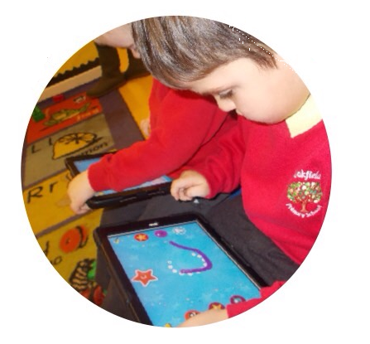

Annual Events and Celebrations
There are a number of annual events that your child will be involved in and we value your support and contribution to these events.
These include:
• Christmas Concert and Party
• St David’s Day, Easter and Mothering Sunday Celebrations
• Multicultural Celebrations – Diwali and Chinese New Year
• Sports Day
• World Book Day
• Summer Picnics
• Community Visits – Garden Centre, Shops, Post Office, Library etc.
• School Trips – such as Noah’s Ark Zoo,
• Nursery Graduation

These are just some of the activities that we plan for the children in order to broaden their experiential learning.
We also invite visitors into the Nursery to talk and work with the children. For example, Zoo Lab, Domino’s Pizza, Cardiff Bus and Vets/Police/Road Safety workers.

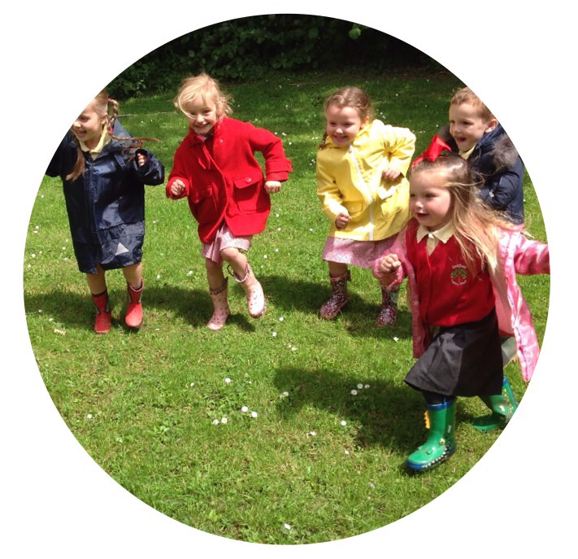

Curriculum
Teaching and learning in Nursery will follow ‘The New Curriculum for Wales’ 6 Areas of learning.
New Curriculum for Wales aims to develop pupils who will be:
- ambitious capable learners
- healthy confident individuals
- enterprising, creative contributors
- ethically informed citizens.

The Six Areas of Learning are:

- Language, Literacy and Communication (English and Welsh)
- Mathematics and Numeracy
- Humanities
- Science and Technology
- Expressive Arts
- Health and Well Being

Young children learn most effectively through structured play and this is what underpins learning within the Early Years environment.

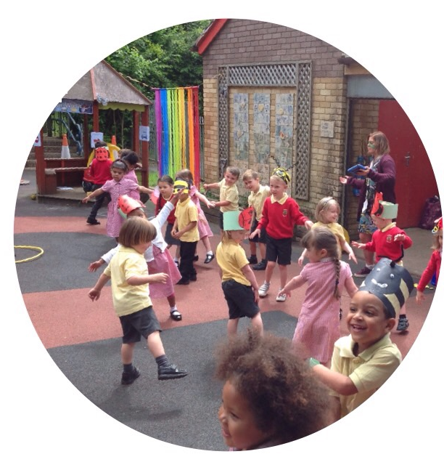

Language, Literacy and Communication
(English and Welsh)
Developing communication and language skills in both English and Welsh is at the core of everything we do at Oakfield Nursery.
Children will be given opportunities to:
- Take part in class discussions – sharing their own experiences and news from home.
- Listen to and enjoy a wide range of stories during – fostering an interest in reading.
- Develop a growing range of vocabulary during Rhyme Time.
- Take a library book home each week to share with an adult.
- Experiment with a range of mark-making materials and develop early writing skills.
- Recognise familiar words, sounds and shapes of letters during our SFA phonics sessions (after Autumn Term).
- Develop their speaking and listening skills through imaginative play activities.
Welsh Language Development
Children will be given the opportunity to develop their Welsh Language skills by:
- Learning to understand and respond to simple instructions and questions in Welsh.
- Listening to and joining in with Welsh nursery rhymes.
- Being encouraged to communicate their needs in Welsh.
- Being encouraged to choose and use Welsh reading materials.
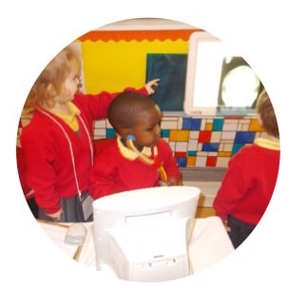
- Listening to a wide range of stimuli, including audio-visual material and ICT interactive software in Welsh.
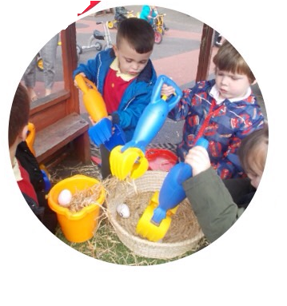

Mathematics and Numeracy
We use practical activities to develop mathematical skills and language.

Children will be the given opportunities to:

- Gain experience and confidence in counting, matching, sorting, ordering and comparing.
- Learn about shape and pattern
- Explore ways of measuring time, volume and capacity.
- Play games during ‘Little Big Maths’ sessions to develop their skills, knowledge and understanding of mathematics.
- Enjoy using and applying mathematics in practical tasks and real life problems.
- Use ICT resources as tools for exploring number, reading and recording data and matching and sorting.

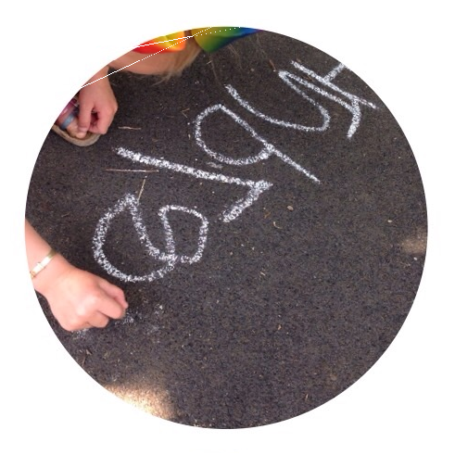

Health and Well-Being
Personal, Social and Physical Development
Children will be given the opportunities to:

- Learn about themselves, their relationships with others both within and beyond the family.
- Develop self-esteem, their personal beliefs and moral values.
- Develop an understanding that others have differing needs, abilities, beliefs and views.
- To celebrate different cultures and develop a positive awareness of their own and others cultures, recognising the value of living in a multicultural Wales.
- Become increasingly aware of traditions and celebrations that are important aspects of the cultures within Wales.
- Develop a positive attitude to learning.
- Become confident, competent and independent thinkers and learners.
- Develop an awareness of their environment and learn about the diversity of people who live and work there.
- Develop positive attitudes towards caring for the environment.
- Express their feelings and empathise with others.
Physical Development
Children will be given the opportunity to:

- Develop physically, using their bodies effectively.
- Develop spatial awareness, balance, control and co-ordination
- Develop their gross and fine motor and manipulative skills.
- Develop physical control, mobility.
- Use a range of large and small equipment.
- Enjoy physical activity.
- Develop their sense of identity through self-image, self- esteem and confidence.
- Develop their awareness of health, hygiene and safety and the importance of diet, rest, sleep and exercise

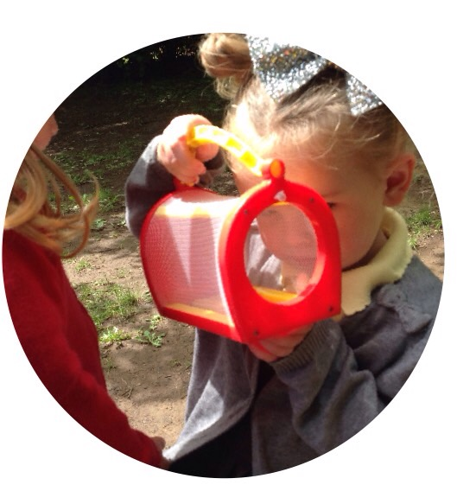

Humanities
History, Geography and Religious Education
Begin to understand past events, people and places.

- Increase their curiosity about the world around them.
- Learn through participation in experiential learning activities and through the use of sources such as stories, photographs, maps, models and ICT.
- Express their own ideas, opinions and feelings with imagination, creativity and sensitivity.
- Become aware of religious events and people. To take part in festivals and celebrations.
- Become increasingly aware of traditions and celebrations that are important aspects of the cultures within Wales.
- Develop their skills to communicate using a range of appropriate vocabulary.

Science and Technology
Science, D.T and ICT
Science
Children will be given the opportunity to:
Our SFA topics are all science-based and promote experiential learning to allow children to make sense of themselves and the world around them. Children will experience the familiar world through enquiry, investigating the indoor and outdoor environment in a safe and systematic way.

They will be given experiences which will help them to:

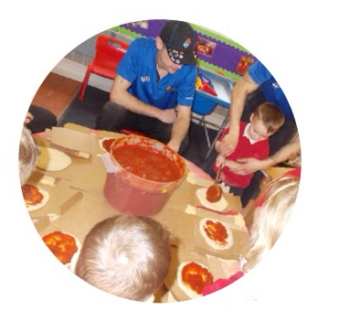

- Use all their senses.
- Enjoy learning through exploration, enquiry, experimentation and asking questions and trying to find answers.
- Develop the skill to communicate using a range of appropriate vocabulary.
- Learn to demonstrate care, responsibility, concern and respect for all living things and the environment.
- Experiment with a range of tools and equipment.
- Investigate the characteristics of the different seasons.
- To explore a range of activities that develop scientific thinking.

We also develop children’s Digital Competency (ICT) skills through all areas of our curriculum.
At Oakfield Nursery, children begin to:

• Understand the uses of ICT.
• Use iPads to take pictures and record sound/videos.
• Access computers and iPads to practise their number and letter formation as well as count, match and sort objects.
• Begin to develop simple programming skills using our ‘Beet-Bots’.

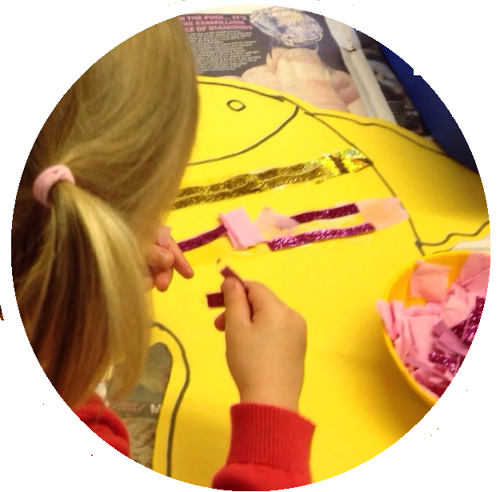

Expressive Arts
Art, Music and Drama
Children will be given the opportunity to:

- Sing and use simple musical instruments.
- Explore different sound sources.
- Join in with music and singing sessions.
- Make varied body shapes and move creatively.
- Use a variety of art materials such as dough, clay, paint, chalk, gloop and foam.
- Explore colour and texture.
- Demonstrate an awareness of roles through imaginative play.

Outdoor Learning
Children in Nursery have open access to the outdoor area and take part in weekly ‘Forest School’ sessions. We consider our outdoor area as an ‘outside classroom’, as we greatly value the learning opportunities that the outdoor environment offers to young children.
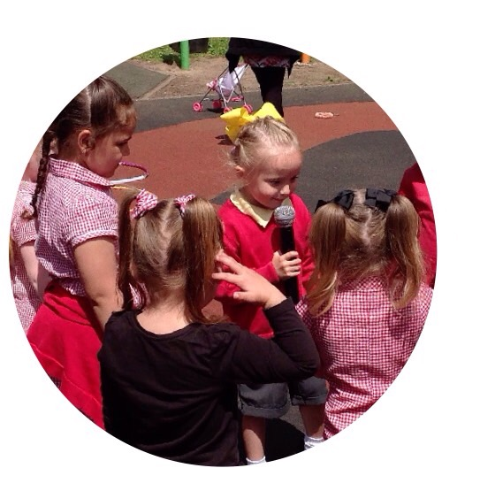
We hope that you appreciate that there can be times when the children’s trousers, socks or tights may get dirty!

